**Charity Clay Shoot**

**Sat 3rd Sept**

**200 Club Winners List**

Because there are less events to publicise now that the new hall has been completed, We have decided to issue just two newsletters per year, Summer and Spring, to save on print costs. Therefore to save space on the newsletter, the 200 club winners list will be put on the parish hall page of the website in the new year and thereafter it will be updated on a monthly basis. For those members who do not have use of the internet, please contact Mary or Tania and we will gladly get a copy of the list to you.

** Free Two**

**Course Community Lunch**

**Friday 14th Oct**

12 Noon for 12.30 pm

Prepared by the Ladies’ Committee. *Raffle* to help cover cost of food.

Booking essential by **8th Oct Sonia on 01363 866 864**

****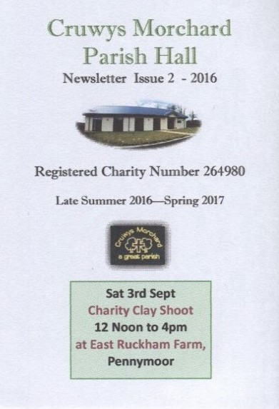

**Parish Hall Management Committee Changes**

We were sad that Guy Cruwys decided to resign after fifteen years as Chairman of the management committee. We are also sorry to loose Rod Chisholm, who has looked after the old hall for many years and also did a lot of carpentry and care-taking at the new hall. Their help and advice has been invaluable and their skills will be greatly missed. The committee would like to say a HUGE ‘thank you’ and wish them both well in their retirement. Paul Steele has a new post as Chairman, & Les Tosdevin as Vice Chair. New member Mrs Sam Ratcliffe is now our Treasurer. It is good to see young people joining us. A big thank you to committee members and all who help to keep the hall and outdoor spaces clean and tidy. Remember you don’t need to join the committee to help look after our hall. *Contact details for the committee and hall bookings are on the back page.*

**200 Club:** This year’s final draw will be on Fri 23rd Dec, just before the Christmas Bingo begins. **Tickets** will be on sale for next year from January. The draw year will run from March to December 2017 with the first draw at our Pink Bingo on March 25th. Tickets cost just £5 per year and it raises just under £500 annually for parish hall funds which is a registered charity. Draws take place in public at the monthly bingo. Existing members will get a visit between January and March. Anyone who would like to join in the new year, please contact the 200 Club Secretary, Mary on **01884 860 620 or text 07773 36 23 05,** or use the ‘Contact Us’ page on the parish website.

[http://www.cruwysmorchardparish.co.uk/#!contact_us/cee5](http://www.cruwysmorchardparish.co.uk/#!contact_us/cee5C:\Users\Mary\Documents\CMPH)



**DI & DAVE’S**

**CHRISTMAS QUIZ**

**SAT 3rd DEC**

**Bar opens at 6.45pm**

**for 7.30pm start.**

Teams of 4 to 6 people, £5 pp to include a light supper.

Cash Prize for winning team.

Please book your team in;

phone 01884 860 620

text 07773 362305 or use the contact us’ page on the parish website. Please leave your

Surname, number, postcode and how many in team,

by 1st Dec, 9 pm for catering

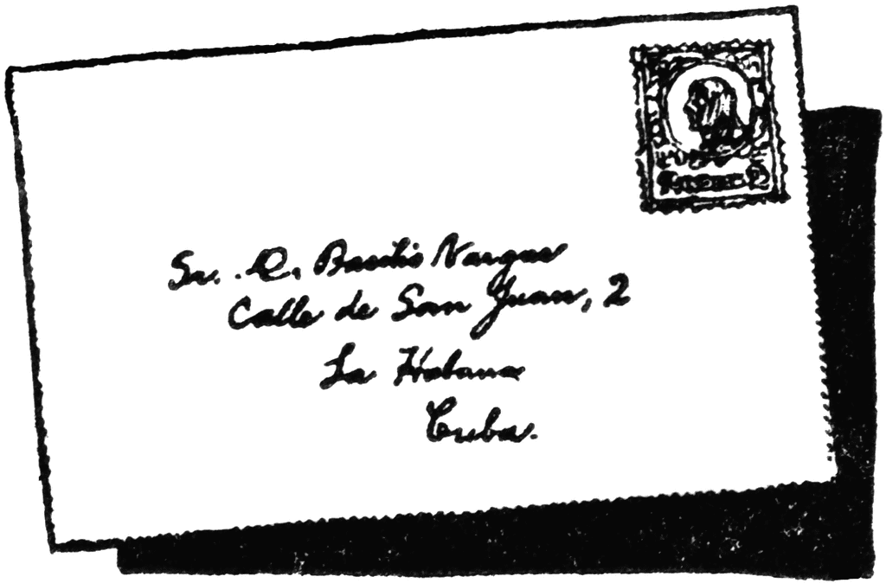

***Please do not send mail***

***to the hall. Please mail***

***to one of the following:-***

**Secretary**: Mrs T Palmer, **Stonehaven, Wayvillage, EX16 8LX**

**Chairman:** Mr Paul Steele,

The Old School House, EX16 8LS

**Treasurer**: Mrs Sam Ratcliffe

6 Moorview, Pennymoor, EX16 8LE

***Hall Hire enquiries/bookings:***

**Mrs D Vincent, 01363 860 227**

Mary Davey—***Newsletter/parish website/Bingo/200 Club/event tickets:*** 01884 860620,

text 07773 36 23 05 or use the ‘contact us’ on parish website.

*Visit the parish website to see what else is happening in the parish, or to enquire about the hall, go to the* ***‘Contact Us’ page* [www.cruwysmorchardparish.co.uk](http://www.cruwysmorchardparish.co.uk)**

*For free inclusion of any parish event or parish organisation event being held elsewhere, on the*

***PARISH WEBSITE ‘WHAT’S ON ‘ PAGE***

*Please email your poster or details with an image to*

**cruwysmorchardwebsite@btinternet.com**

Or use the ‘contact us’ page

**www.cruwysmorchardparish.co.uk**

***Diary of Events***

***2016 to Spring 2017***

**Sat 3rd Sept** Clay Shoot

East Ruckham, Pennymoor 12 to 4pm

**Sat 24th & 25th Sept** Harvest Celebrations including a community tea party at the hall. *(Please look for posters or check website for details). Note: No Bingo in Sept.*

**Sat 29th Oct Hall Bingo**

*Doors open at 7.30pm , eyes down 8pm. Dinners for full house and other good prizes. Cash flyer.*

**Sat 26th Nov Hall Bingo**

*Details as above*

**Sat 3rd Dec Quiz Night**

Di & Dave’s Christmas Quiz

See centre pages for details

**Fri 23rd Dec 7pm (8pm)Christmas Bingo & final 200 Club draw at 7.45pm**

**2017 March** Parish Hall AGM **8pm (**Date to be confirmed).

All parishioners welcome.

**Sat 25th March 7.30pm (8pm)**)

Pink Bingo—half profit for Breast Cancer Care.

**Sat 8th or 15th April (TBC)**

Di & Dave’s Spring Quiz 7pm

Please check the parish website for other events.

**www.cruwysmorchardparish.co.uk**

